Robert A. Leach, D.C., M.S.
Alternate Delegate, American Chiropractic Association
Research Chairman, Mississippi Chiropractic Association
Fellow, International College of Chiropractors (FICC)
Certified Health Education Specialist (CHES)

Robert A. Leach, Jr., L.M.T.
Licensed Massage Therapist (LMT2002)

May 2017 Newsletter

Neck Posture: Addressing a Cause of Neck Pain and Disability

Patients & Friends,

Nearly 35 years ago the findings of my observations on neck curve correction after chiropractic were the first ever published in peer review biomedical literature. Based on observations made in our practice here in Starkville, even after only a dozen chiropractic sessions, patients began to see improvement in abnormal neck posture (such as a straight neck observed on the side view—like the neck shown here). Sometimes the improvement was seen after just 1-2 months of treatment. 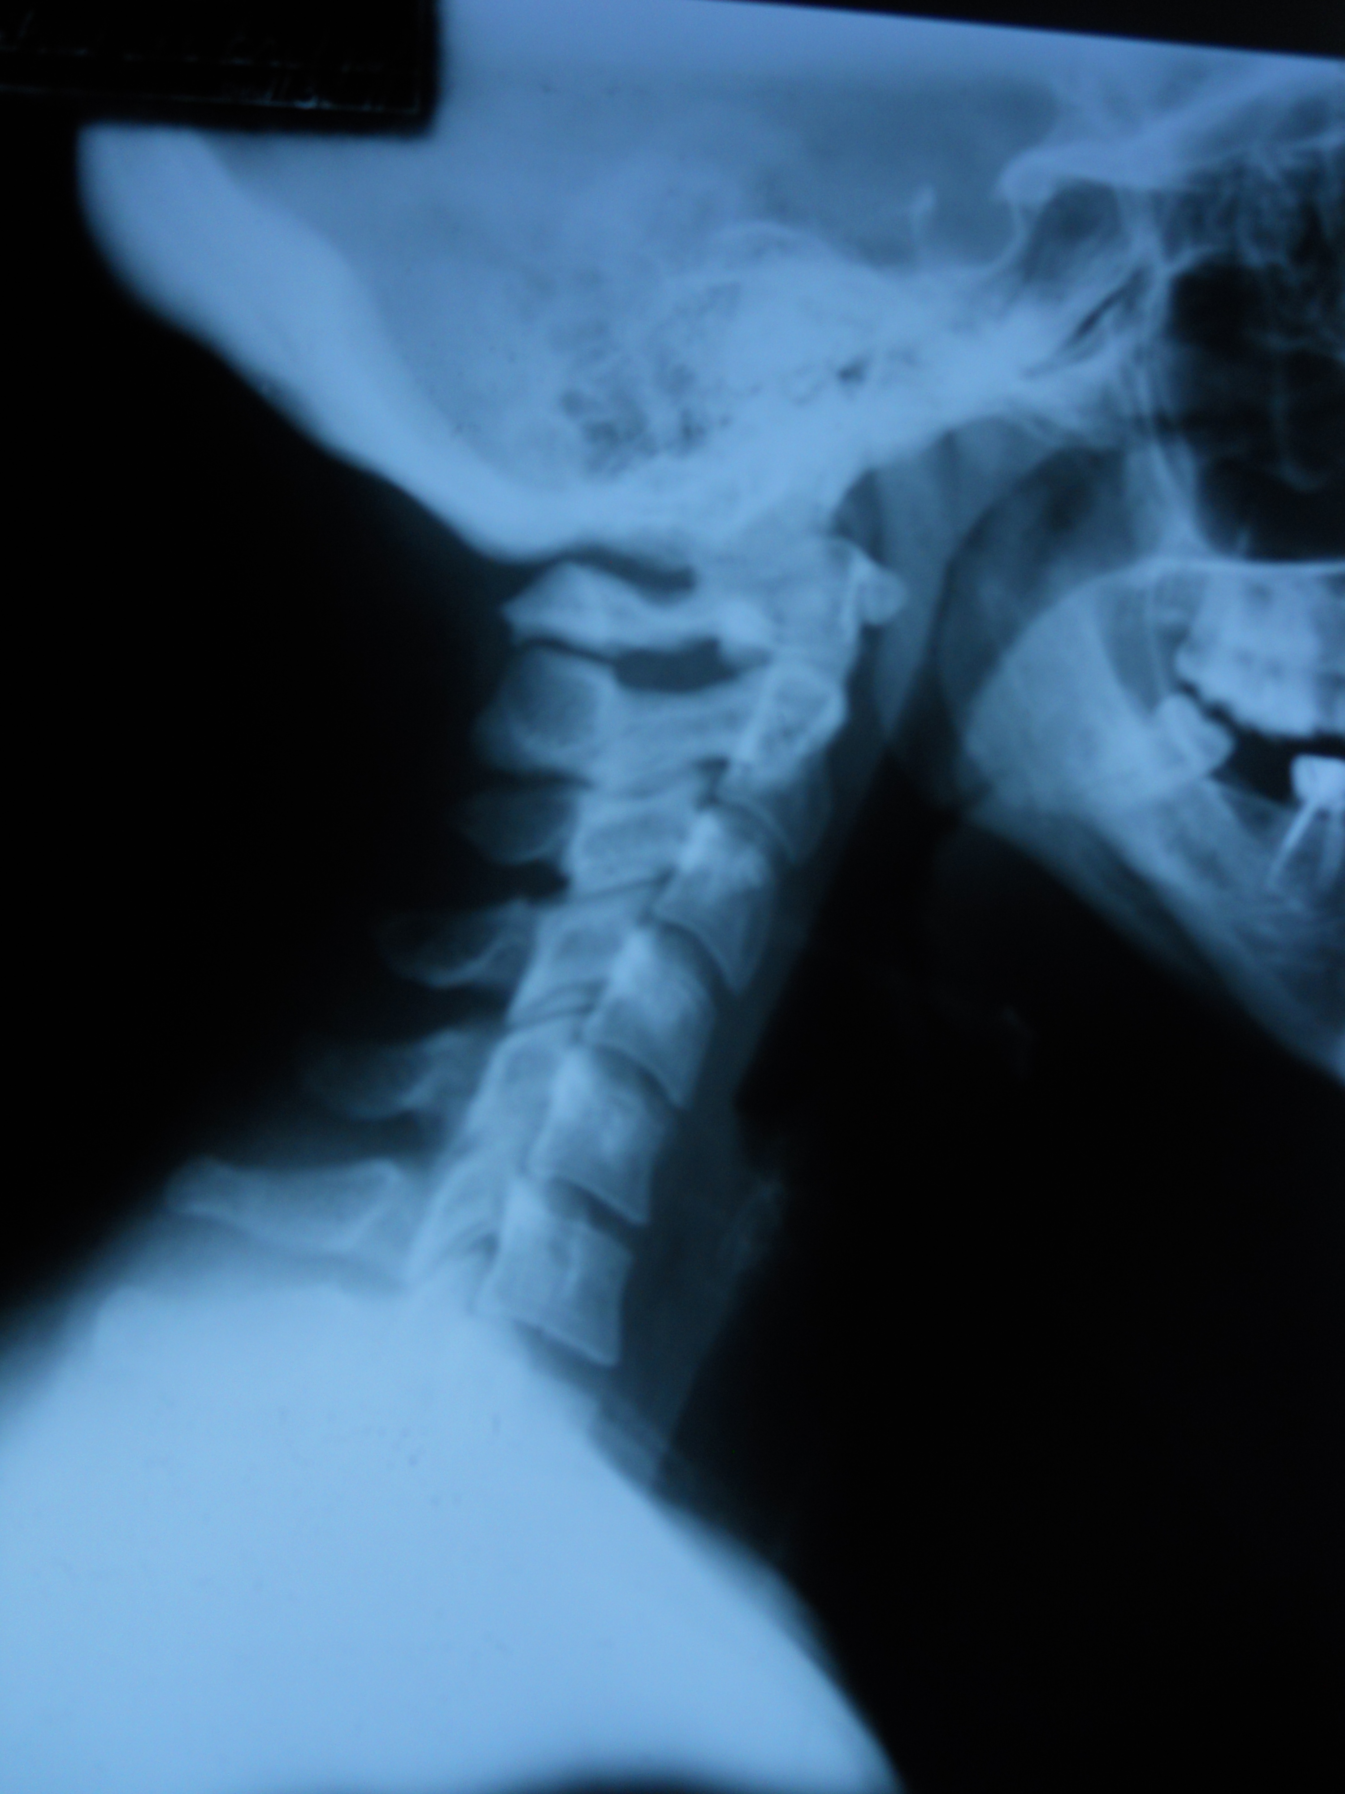
Since that time, articles in chiropractic, physical therapy, and neurosurgery journals have reported how correction of faulty neck posture may impact health.
Recently physical therapists and a chiropractor reported in the Archives of Physical Medicine and Rehabilitation that patients receiving standard care did not maintain improvement in neck and arm pain, function and disability as well as patients receiving neck manipulation, exercise, and in-home traction, at 1 year follow up.
Following up on earlier studies by Don Harrison, D.C., Ph.D., the scientists speculated that improvement in neck posture—cervical lordosis and anterior head tilt—associated with the treatment, may have been responsible for the findings.
Scientists in China independently confirmed abnormal sagittal (side view) spinal postures predict the presence of neck pain, neck pain severity, and disability, in a study published in Manual Therapy.
Last month surgeons reported that improving the cervical lordosis (neck curve as seen from the side) “remains a major goal of surgery” and report that cervical kyphosis (reversed neck curve) should be eliminated in patients with neck pain, for best results.
It’s too early to know for sure how large a role postural abnormality may play, since a number of factors may be important predictors of neck pain and disability, such as: sedentary lifestyle, obesity, smoking, stress, diet and presence of inflammatory markers in the blood, prior injury, and genetic predisposition to degenerative arthritis.
That said, it’s time to take a serious look at a possible role for chiropractic correction of neck posture, and the role it may play in treatment and prevention of neck pain and disability.

Sincerely,
Robert A. Leach, DC, MS, FICC(h), CHES

Further Resources:

- First observations on improvement in the cervical lordosis after chiropractic care were reported by Leach in 1983: https://www.ncbi.nlm.nih.gov/pubmed/6854156
- Moustafa and co-workers reported that patients who used a Dennerol neck traction device for daily use at home—in addition to multi-modal care that included muscle stimulation, thoracic spine manipulation, mobilization to the neck and spine muscles, and strengthening exercises 3x per week for 10 weeks--had better results in posture, disk related neck and arm pain and disability a year later, compared with multi-modal care only: https://www.ncbi.nlm.nih.gov/pubmed/27576192
- A follow up paper by Moustafa et al published in the European Journal of Physical Medicine and Rehabilitation, reported that improvement in neck arthritis pain and related dizziness was longer lasting in patients randomized to Dennerol neck traction in addition to spinal manipulation and strengthening exercises, achieving significantly better results at a 1-year follow up: https://www.ncbi.nlm.nih.gov/pubmed/27575013
- Lau and co-workers published a paper in Manual Therapy in 2010 that confirmed that the upper thoracic angle was even better than the craniovertebral angle in predicting the presence and severity of neck pain and disability: https://www.ncbi.nlm.nih.gov/pubmed/20430685
- Harrison and co-workers found that 2-way cervical traction techniques combined with chiropractic adjustments resulted in improved neck posture (side view, cervical curve) as well as reduced chronic neck pain: https://www.ncbi.nlm.nih.gov/pubmed/12704306
- Inflammatory mediators and chemokines such as nitric oxide are important in the pathogenesis of and predict the presence of neck pain: https://www.ncbi.nlm.nih.gov/pubmed/21978542
- Even patients with severe problems such as MR confirmed cervical herniated disks may benefit from chiropractic, such as 85.7% of those after just 3 months of care in this trial in 2013. Whether further postural chiropractic postural correction helps prevent recurrence of disk symptoms has not been explored: https://www.ncbi.nlm.nih.gov/pubmed/23948425

If you are viewing a paper or hotmail copy of this newsletter, you may view the references associated with the hyperlinks by accessing our newsletters at www.drleach.com and clicking on NEWSLETTERS, 2017 and then: Neck Posture: Addressing a Cause of Neck Pain and Disability

Excellence in Conservative Spine Care... ...Excellence in Health
214 Russell St., Box 80121, Website: DrLeach.com
Starkville, Ms 39759 e-mail:
Phone: (662) 323-2371 FAX: (662) 323-2382

