Robert A. Leach, D.C., M.S.
Alternate Delegate, American Chiropractic Association
Research Chairman, Mississippi Chiropractic Association
Fellow, International College of Chiropractors (FICC)
Certified Health Education Specialist (CHES)

March 2017 Newsletter
The Research is in: Is it Time to End Discrimination
Against Patients With Medicare who seek Chiropractic Care?
Since 1972 when Congress first authorized coverage for chiropractic in the Medicare program, only one service has been covered: manual adjustment of the spine to reduce a chiropractic subluxation.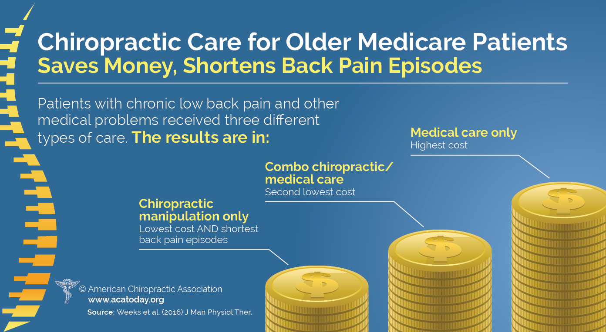
Of physician-level providers in the Medicare program, only patients of chiropractors have no coverage for exams, x-rays, or even other necessary therapeutic procedures and exercise instruction. In 1972 such a cost-saving provision may have made sense. While there was a public outcry to include the popular treatment in the Federal program for seniors and persons with disabilities, there was no research to substantiate either the effectiveness, cost-effectiveness, or safety of spinal manipulation, the primary treatment. Since that time much has changed. A sample of just a few of the many recent major studies reveals:
- Among 72,326 seniors with chronic low back pain and multiple medical problems, Medicare beneficiaries who received only chiropractic treatment had lower overall costs of care, shorter episodes, and lower incidence of back surgery a year later compared with patients who sought care from a medical doctor.
- Medicare beneficiaries seeing a chiropractor had slower decline in activities of daily living disabilities, lifting, stooping, walking, self-rated health, and worsening health after one year, compared with patients receiving usual medical care, based on analysis of 12, 170 person years of data.
- Greater supply and use of chiropractors is associated with lower rates of opioid prescriptions among younger Medicare beneficiaries.
- In a study of 17.7 million Medicare patients as the supply of chiropractors increased, visits to primary care physicians for back and/or neck pain decreased.
- Recent large studies of patients with commercial insurance or Medicare Advantage revealed no associations between vertebral or carotid artery dissection and chiropractic care. Scientists concluded that associations reported in case reports are likely due to patients going to a chiropractor while having symptoms of a stroke in progress.
- Analysis of Medicare data for 2007 to determine relative safety of chiropractic for senior citizens, revealed that risk of secondary injury after chiropractic care was 40 incidents per 100,000, lower than for patients seeking primary or orthopedic care, where there were 153 incidents per 100,000.

After 45 years and mounting research supporting effectiveness, cost benefits, and safety of chiropractic, is it time to end discrimination against patients with Medicare who seek chiropractic care?
Is it time for Medicare to pay for the screening exams required before chiropractic treatment for a new problem? For x-rays when indicated? For guidance and tips for healthy eating and lifestyle choices, help with activities of daily living, and exercise counseling and instruction?
Clearly the answer is in the affirmative. The research is in: it’s time to consider ending discrimination against patients with Medicare who choose chiropractic care. Other citizens may appreciate the change as well, when savings from less back surgeries are factored into their tax bill.

Sincerely,

Robert A. Leach, DC, MS, FICC(h), CHES

Further Resources:

- In 2016 Weeks and co-workers reported in the Journal of Manipulative and Physiological Therapeutics results of a review of Medicare payments for chronic low back pain for 72,326 multiply co-morbid beneficiaries for the years 2006-2012 who had chiropractic only, combined, or medical care only, and found lower costs and surgical rates for patients only treated by chiropractors: https://www.ncbi.nlm.nih.gov/pubmed/26907615
- Weigel and co-workers looked at 12,170 person-years of data in Medicare B beneficiaries and concluded patients who received chiropractic care had slower declines in functional (i.e., age related declines in activities of daily living, lifting, stooping, walking, self-rated health, and worsening health) and had higher satisfaction with follow up care 1 year later: https://www.ncbi.nlm.nih.gov/pubmed/25233887
- Using 2011 data, a higher per-capita supply of doctors of chiropractic and Medicare spending on chiropractic adjustments were inversely associated with younger, disabled Medicare beneficiaries obtaining an opioid prescription: https://www.ncbi.nlm.nih.gov/pubmed/27034107
- A study reported in the Journal of the American Board of Family Physicians found that of 17.7 million Medicare beneficiaries enrolled from 2010-2011, as the supply of chiropractors increased, there was a reduction in primary care provider visits for back or neck pain. The study projected that PCPs lost 0.37 million visits at a cost of $83.5 million. https://www.ncbi.nlm.nih.gov/pubmed/26152439
- Kosloff and colleagues reported that of a total of 1,829 vertebral artery strokes reported among commercial and Medicare Advantage patients in the U.S. from 2011-2013, there was an association between strokes and visits to primary care but not chiropractor providers. They concluded that the positive association between PCP visits and stroke is likely due to patients seeking care for the headache and neck pain associated with these lesions: https://www.ncbi.nlm.nih.gov/pubmed/26085925

- Whedon and co-workers reported on a 100% sample of Medicare B beneficiaries aged 66 to 99 including 1.1 million claims where patients complained of neck pain. Differences in risk for subsequent stroke of any type between patients who saw a chiropractor and primary care physician were not clinically significant: https://www.ncbi.nlm.nih.gov/pubmed/25596875
- In another study regarding relative safety of chiropractic care, scientists writing in Spine Journal reported that the risk of traumatic injury for all Medicare B beneficiaries after presenting with a neuromusculoskeletal complaint was greater for patients seen by a primary care doctor (153 incidents per 100,000) than for those seen by a chiropractor (40 incidents per 100,000): https://www.ncbi.nlm.nih.gov/pubmed/25494315
- Chiropractors—including those in Mississippi—typically advocate for and incorporate into their practices, healthy lifestyle choices and Leading Health Indicators promoted by the U.S. Centers for Disease Control and Prevention: http://www.ncbi.nlm.nih.gov/pubmed/21807263
- Hawk and co-workers reported in the Journal of Manipulative and Physiological Therapeutics that benefits of extended (maintenance) chiropractic included improvement in back disability a year later, when compared with patients receiving only initial chiropractic, or no chiropractic: https://www.ncbi.nlm.nih.gov/pubmed/19712786
- Many studies have explored consistent higher satisfaction with chiropractic for treatment of back pain, while Leininger and co-workers, reporting in the Journal of Manipulative and Physiological Therapeutics, were among the first to suggest patients receiving chiropractic manipulations for neck pain were more satisfied with their general care than were patients randomized to home exercise and advice or to medications: https://www.ncbi.nlm.nih.gov/pmc/articles/PMC4186899/
- Regarding expansion of chiropractic services in Medicare, Whedon and co-workers recommend a dual approach whereby chiropractic and individual physicians work to correct deficiencies in compliance and documentation, while CMS is encouraged to re-examine chiropractic reimbursement using the same standards applicable to other health care providers, at a minimum adding reimbursement for evaluation and management services provided by chiropractic physicians: https://www.ncbi.nlm.nih.gov/pubmed/25067927
- Based on concerns about payments to chiropractic physicians, a study of Medicare Part B claims from 2006 to 2008 published in Spine Journal, revealed that while total spending for physicians increased by 10% per beneficiary, per user spending for chiropractic decreased by 18% during the same period: https://www.ncbi.nlm.nih.gov/pubmed/23773429

If you are viewing a paper or hotmail copy of this newsletter, you may view the references associated with the hyperlinks by accessing our newsletters at www.drleach.com and clicking on NEWSLETTERS, 2017 and then: Is it Time to End Discrimination Against Patients With Medicare Who Seek Chiropractic Care?

Excellence in Conservative Spine Care... ...Excellence in Health
214 Russell St., Box 80121, Website: DrLeach.com
Starkville, Ms 39759 e-mail:
Phone: (662) 323-2371 FAX: (662) 323-2382

